DR. AMBEDKAR COLLEGE, DEEKSHABHOOMI, NAGPUR
DEPARTMENT OF LAW
Academic Session - 2022-2023

NAME OF THE PROGRAMME: | “Guest lecture on Prevention of Immoral Trafficking”
NAME OF THE GUEST SPEAKER | Adv. Vivek Awchat
NAME OF THE PROGRAMME CO-ORDINATOR: | Prof. Dr. Sandhya Kalamdhad
DATE AND DAY: | May 6, 2023, at 6:00 – 7:30pm
TOTAL NUMBER OF PARTICIPANTS: | 45 students
VENUE: | Online session through Google meet link- : https://meet.google.com/rha-wtwe-vuq

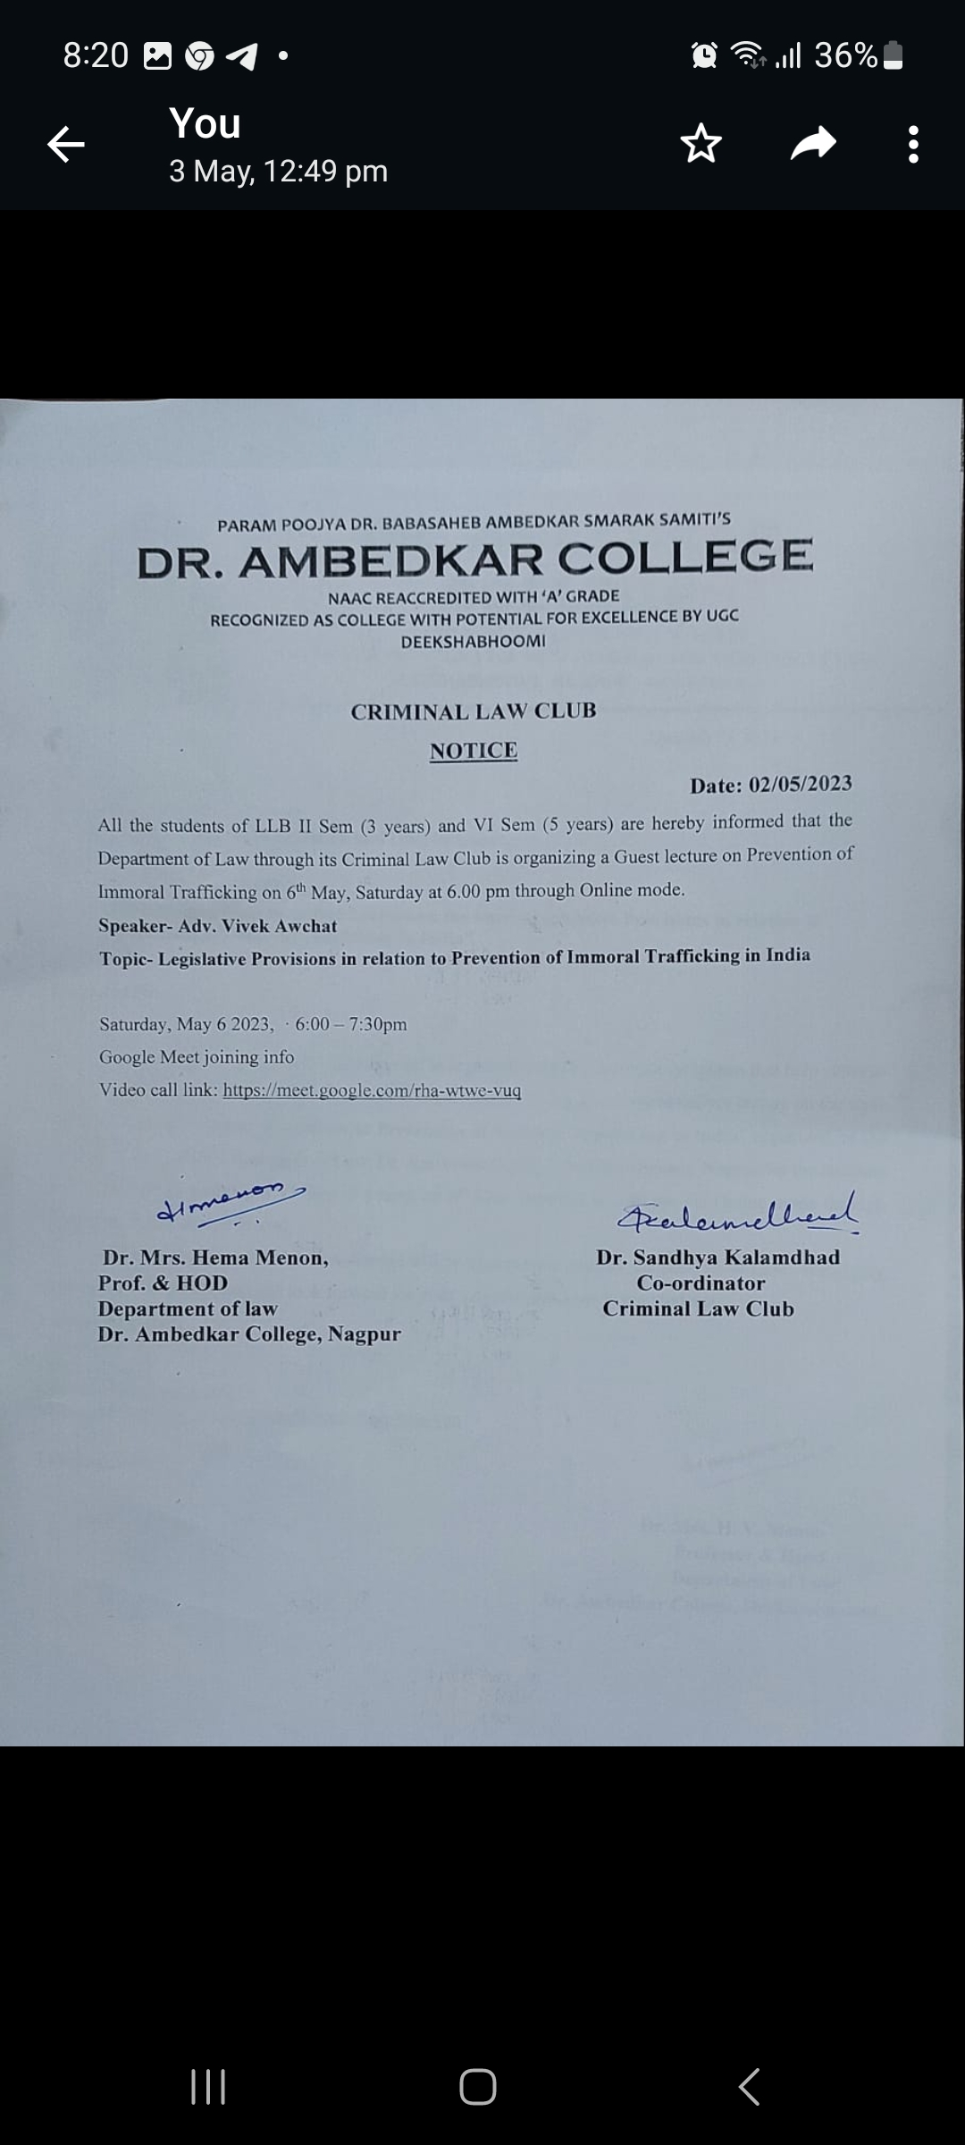
Department of Law through the Criminal Law Club organized a Guest lecture on the topic “Legislative Provisions in relation to Prevention of Immoral Trafficking” on 6th May, Saturday at 6.00 pm through Online mode via Google meet, for the students of LLB II Sem (3 years) and VI Sem (5 years). Total 45 students joined the online session. The program commenced with the welcome address by Head of the Department, Prof. Dr. H.V. Menon.
The Guest Speaker, Adv. Vivek Awchat started the session by sensitizing the students that the problem of Immoral Trafficking is a global phenomenon and highlighted the sensitive real cases on immoral trafficking. He further discussed the various facets of immoral trafficking in India, throwing light on the domestic legislation regarding Prevention of Immoral Trafficking, certain constitutional provisions, and relevant international provisions. Adv. Vivek Awchat enlightened the students about that aspect of sexual exploitation which is covered in the Act of Prevention of Immoral trafficking. He further criticised the enactment for not covering the other aspects of immoral trafficking.
Adv. Awchat further explained the definition of Prostitution and elaborated it with live examples and offences relating to running a brothel, earning funds and financing the brothel and surviving on its earnings. He further explained the structure of investigation and powers of special public officer provided under the statute by citing the example of “Ganga Jamuna” place in Nagpur.
Adv. Awchat concluded the session by emphasizing on the sexual exploitation and other problems of male prostitutes, and criticized the present Act, for failing to address this issue. All the questions were answered by the speaker to the satisfaction of the students. The co-ordinator of Criminal law Club, Dr. Sandhya Kalamdhad conducted the said online Guest lecture and proposed the formal vote of thanks.
Adv. Vivek Awchat addressing the students

